**Experiment 1.4**

**Student Name: Gaurav Kumar                                     UID: 22MCC20177**

**Branch: CC-DEVOPS Section/Group : 1/B**

**Semester: 1                                                                    Date of Performance: 28/Oct/2022**

**Subject Name : Python Programming                         Subject Code: 22CAH645**

1. **Task to be done: Implement a Student class with information such as roll no, name, and class. The information must be entered by the user.**

**Steps for experiment/practical:**

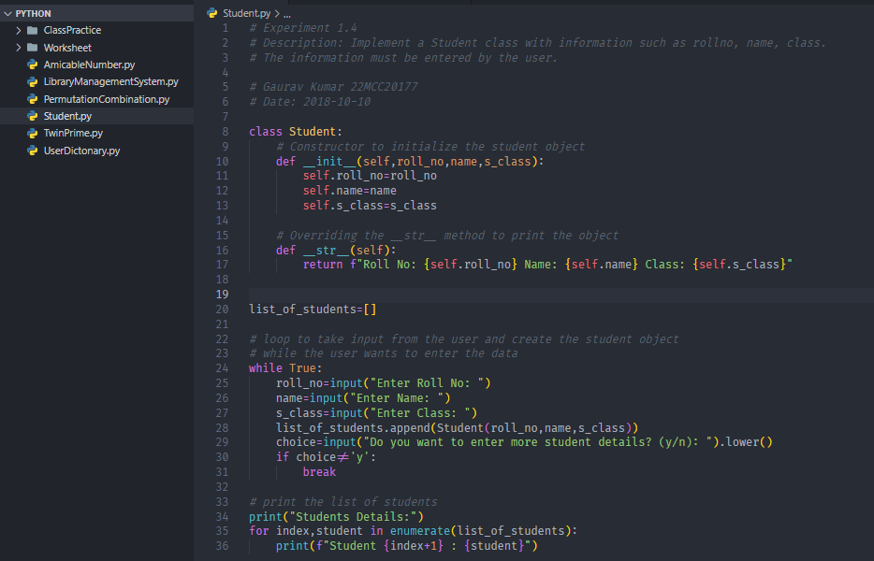

**Output (screenshots):**

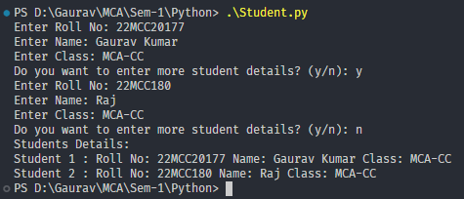

1. **Task to be done: Create a program to implement library management system using classes and objects.**

**Steps for experiment/practical:**

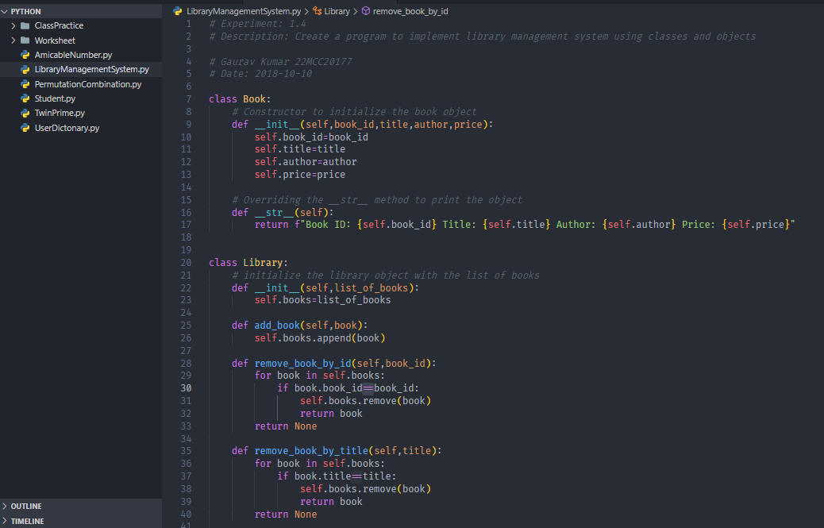

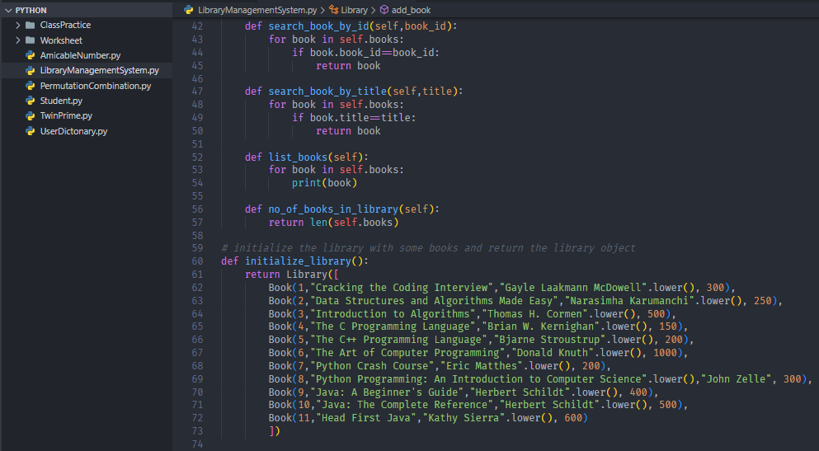

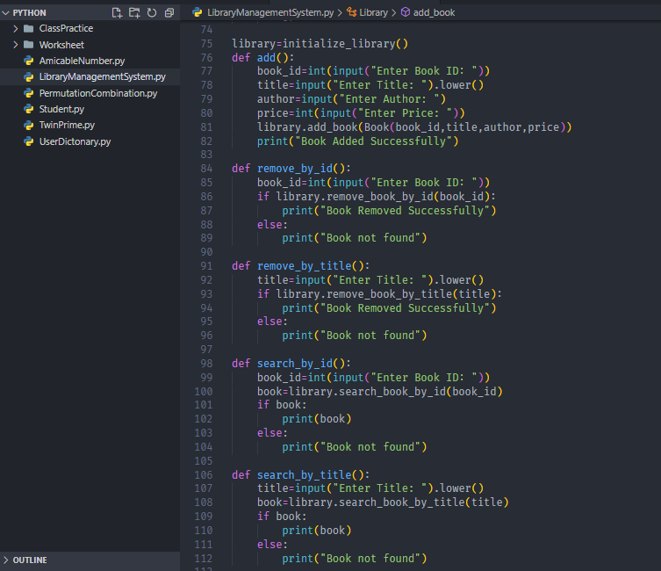

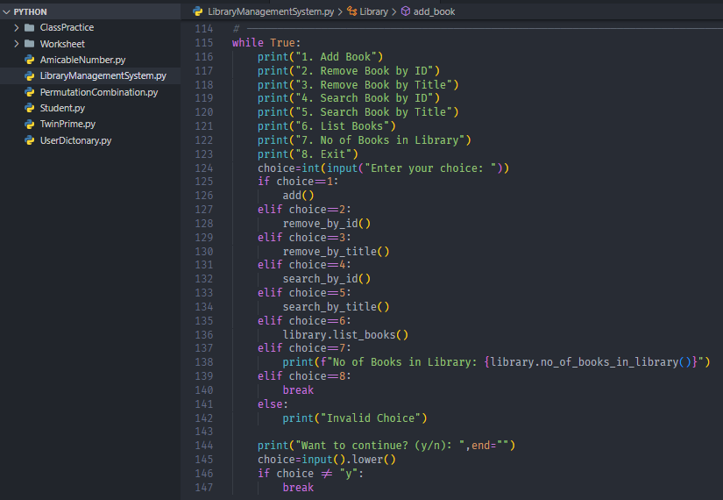

**Output (screenshots)**

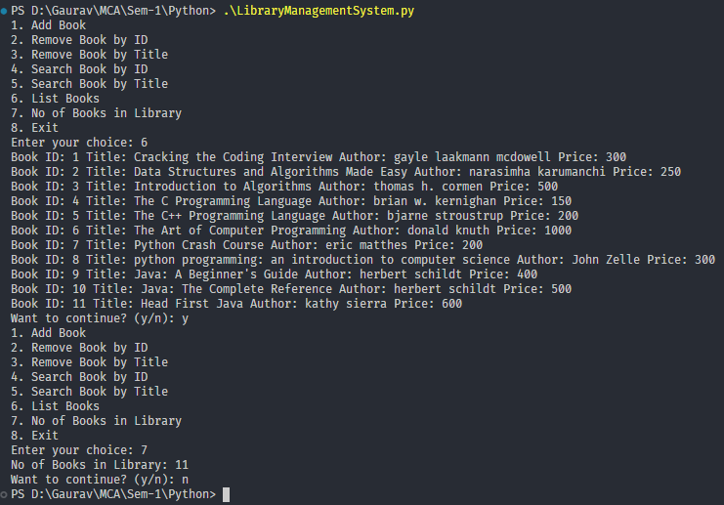

**4) Learning outcomes (What I have learnt): Times new roman 12 size**

**1. Learn about classes and objects.**

**2. Learn about __init__() and __str__() function.**

**3. Learn about use of enumerator in loop**

**Evaluation Grid:**

|  |  |  |  |
| --- | --- | --- | --- |
| Sr. No. | Parameters | Marks Obtained | Maximum Marks |
| 1. | Demonstration and Performance  (Quiz) |  | 22 |
| 2. | Worksheet |  | 8 |